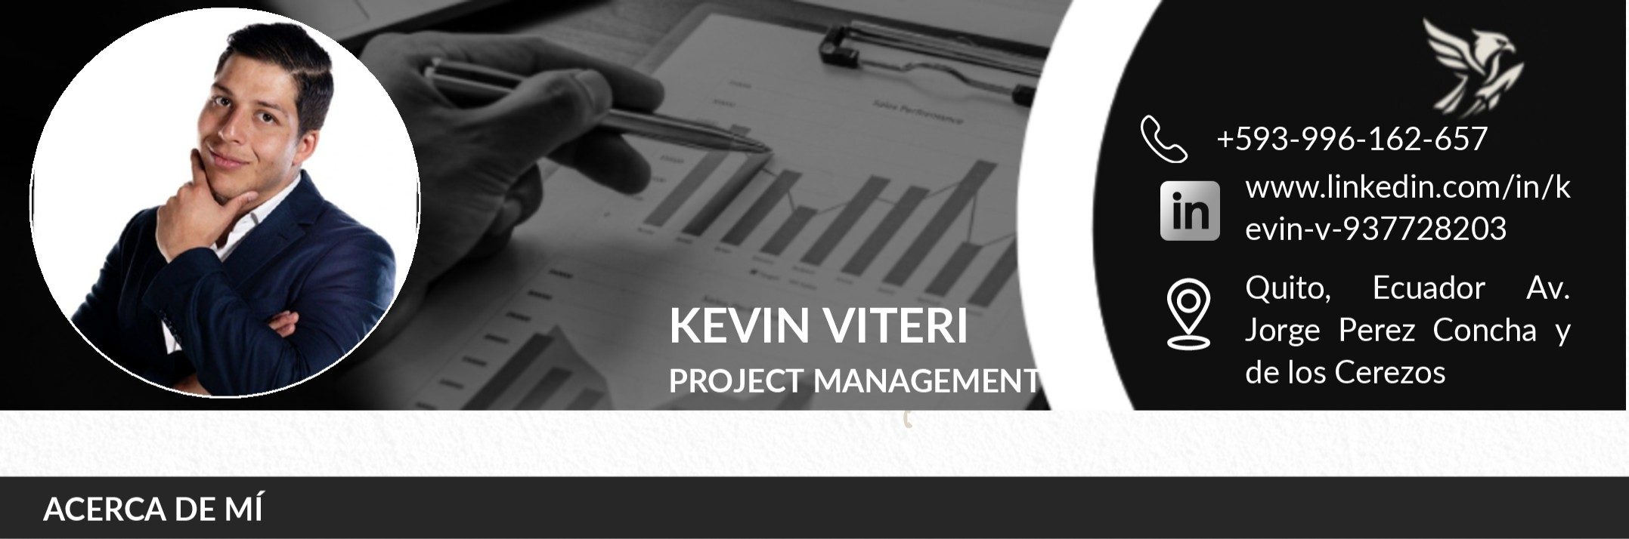
PROFESSIONAL SUMMARY

Project Manager with over 5 years of experience leading technological and industrial projects. Certified in PMP and Agile methodologies (Scrum, Kanban, OKR), specialized in process automation, strategic project planning, and multidisciplinary team leadership. Achieved up to 30% reduction in delivery times through process optimization and automation. Currently combining professional experience with academic teaching, mentoring innovation and graduation projects for university students. Seeking new global challenges in remote or hybrid environments where innovation, digital transformation, and people-centered strategies generate measurable impact.

WORK EXPERIENCE
PUCE – Pontificia Universidad Católica del Ecuador/ Lecturer & Coordinator of Graduation / Jan 2025 – Present

- Designed and implemented the graduation process for the 2024 cycle.
- Mentored students in innovation projects, with award-winning teams recognized by PMI Andes Pacífico.
- Teaching subjects: Leadership, Project Management, and Programming.
Conta RS – Digital Transformation Leader(Freelance) / Digital Transformation Leader / Jan 2021 – Present

- Drove digital transformation in accounting processes through automation, reducing delivery times by 30%.
- Coordinated software development teams for SME clients.Establecí una cultura de mejora continua aplicando herramientas ágiles y OKR's, capacitando al personal.
- Established a continuous improvement culture with Agile practices and OKRs.
Ecuadorian-German Chamber of Commerce (Freelance) / Consultant & Lecturer – Dual Education Program / Jan 2025 – Present

- Training for pharmaceutical operators in quality tools (Ishikawa, Pareto, 5 Whys, Ikigai).
- Consulting in budgeting, laboratory design, and industrial automation/digitalization.
Maquipharma S.A.S/ Maintenance Supervisor / Jul 2021 – Dec 2024

- Implemented TPM and ISO 9001-based processes, improving productivity and reducing critical failures.Dirigí proyectos de automatización y despliegue de la herramienta SAP.
- Led automation projects and SAP deployment.
- Managed technical teams, KPIs, and OKRs aligned with corporate mission.
TOTEM/ Junior Developer - Jan 2019 – Mar 2021
- Developed software solutions for financial institutions.
- Participated in Agile project management and digital product development.
- Supported continuous improvement and stakeholder management.

SOFT SKILLS

- Effective communication with stakeholders and team
- Strategic thinking and decision-making
- Conflict resolution and negotiation
- Adaptability and resilience in changing environments
- Multidisciplinary team leadership
TECHNICAL SKILLS

- Agile Project Management (Scrum, Kanban, OKRs)
- Tools: JIRA, MS Project, Miro, Confluence and Trello
- TPM and process automation
- Data analysis and dashboard development
- Git version control & Python (intermediate-advanced)
EDUCATION
- Master in Project Management (Msg.) – Universidad Europea de Monterrey (2023–2024)
- MBA – Instituto Europeo de Posgrados (2023–2024)
- B.Sc. in Mechatronics Engineering – Universidad de las Fuerzas Armadas ESPE (2015–2023)
- B2 English Certificate – Universidad de las Fuerzas Armadas ESPE
- High School Diploma – Colegio Marista (2007–2014)
CERTIFICATIONS & COURSES
- PMP-PMI-(In Preparation)
- Agile Project Management Expert (SCRUM-KANBAN) – CCE (2025)
- University Teaching Diploma – PUCE (2025)
- Applied Data Science with Python – IBM (2025)
- Artificial Intelligence Fundamentals with Capstone Project – IBM (2025)
- Data Fundamentals & Project Management – IBM (2025)
- Intellectual Property Training – CEDIA (2025)
- Organizational Leadership – Universidad Santander (2024)
- The Basics of Scrum – PMI (2024)
- Generative AI for Project Managers – PMI (2024)
- Finance for Non-Financials – UDLA (2024)
- Agile Methodologies with OKRs – Universidad Santander (2023)
- Financial Evaluation of Projects – Politécnico de Colombia (2022)
- WFI Water Systems Supervision – BRAM COR (2021)
PROFESSIONAL REFERENCES
- Development Coordinator PUCE: Diana Molina +593-987-721-889
- Operations Manager Conta RS : Rocío Saltos +593-996-036-210
- Business Coordinator AHK: Ricardo Cevallos +593-987-062-105
- Maintenance Manager Maquipharma: William Baque +593-999-061-348
- Development Manager: Patricio Espinosa +593-987-041-140
REFERENCIAS PERSONALES

- Project Management BVA-Mexico: Renzo Camaño +52-556-088-4021
- Doctor: Paul Proaño: +593-984-931-621
- Commercial and Customer Sucess Leader ICOMM: Lenin Cueva +593-998-116-991

Kevin Viteri

Project Manager with over 5 years of experience leading technological and industrial projects. Certified in PMP and Agile methodologies (Scrum, Kanban, OKR), specialized in process automation, strategic project planning, and multidisciplinary team leadership. Achieved up to 30% reduction in delivery times through process optimization and automation. Currently combining professional experience with academic teaching, mentoring innovation and graduation projects for university students. Seeking new global challenges in remote or hybrid environments where innovation, digital transformation, and people-centered strategies generate measurable impact.

WORK EXPERIENCE
PUCE – Pontificia Universidad Católica del Ecuador/ Lecturer & Coordinator of Graduation / Jan 2025 – Present

- Designed and implemented the graduation process for the 2024 cycle.
- Mentored students in innovation projects, with award-winning teams recognized by PMI Andes Pacífico.
- Teaching subjects: Leadership, Project Management, and Programming.
Conta RS – Digital Transformation Leader(Freelance) / Digital Transformation Leader / Jan 2021 – Present

- Drove digital transformation in accounting processes through automation, reducing delivery times by 30%.
- Coordinated software development teams for SME clients.Establecí una cultura de mejora continua aplicando herramientas ágiles y OKR's, capacitando al personal.
- Established a continuous improvement culture with Agile practices and OKRs.
Ecuadorian-German Chamber of Commerce (Freelance) / Consultant & Lecturer – Dual Education Program / Jan 2025 – Present

- Training for pharmaceutical operators in quality tools (Ishikawa, Pareto, 5 Whys, Ikigai).
- Consulting in budgeting, laboratory design, and industrial automation/digitalization.
Maquipharma S.A.S/ Maintenance Supervisor / Jul 2021 – Dec 2024

- Implemented TPM and ISO 9001-based processes, improving productivity and reducing critical failures.Dirigí proyectos de automatización y despliegue de la herramienta SAP.
- Led automation projects and SAP deployment.
- Managed technical teams, KPIs, and OKRs aligned with corporate mission.
TOTEM/ Junior Developer - Jan 2019 – Mar 2021
- Developed software solutions for financial institutions.
- Participated in Agile project management and digital product development.
- Supported continuous improvement and stakeholder management.

SOFT SKILLS

- Effective communication with stakeholders and team
- Strategic thinking and decision-making
- Conflict resolution and negotiation
- Adaptability and resilience in changing environments
- Multidisciplinary team leadership
TECHNICAL SKILLS

- Agile Project Management (Scrum, Kanban, OKRs)
- Tools: JIRA, MS Project, Miro, Confluence and Trello
- TPM and process automation
- Data analysis and dashboard development
- Git version control & Python (intermediate-advanced)
EDUCATION
- Master in Project Management (Msg.) – Universidad Europea de Monterrey (2023–2024)
- MBA – Instituto Europeo de Posgrados (2023–2024)
- B.Sc. in Mechatronics Engineering – Universidad de las Fuerzas Armadas ESPE (2015–2023)
- B2 English Certificate – Universidad de las Fuerzas Armadas ESPE
- High School Diploma – Colegio Marista (2007–2014)
CERTIFICATIONS & COURSES
- PMP-PMI-(In Preparation)
- Agile Project Management Expert (SCRUM-KANBAN) – CCE (2025)
- University Teaching Diploma – PUCE (2025)
- Applied Data Science with Python – IBM (2025)
- Artificial Intelligence Fundamentals with Capstone Project – IBM (2025)
- Data Fundamentals & Project Management – IBM (2025)
- Intellectual Property Training – CEDIA (2025)
- Organizational Leadership – Universidad Santander (2024)
- The Basics of Scrum – PMI (2024)
- Generative AI for Project Managers – PMI (2024)
- Finance for Non-Financials – UDLA (2024)
- Agile Methodologies with OKRs – Universidad Santander (2023)
- Financial Evaluation of Projects – Politécnico de Colombia (2022)
- WFI Water Systems Supervision – BRAM COR (2021)
PROFESSIONAL REFERENCES
- Development Coordinator PUCE: Diana Molina +593-987-721-889
- Operations Manager Conta RS : Rocío Saltos +593-996-036-210
- Business Coordinator AHK: Ricardo Cevallos +593-987-062-105
- Maintenance Manager Maquipharma: William Baque +593-999-061-348
- Development Manager: Patricio Espinosa +593-987-041-140
REFERENCIAS PERSONALES

- Project Management BVA-Mexico: Renzo Camaño +52-556-088-4021
- Doctor: Paul Proaño: +593-984-931-621
- Commercial and Customer Sucess Leader ICOMM: Lenin Cueva +593-998-116-991

